Project Outputs along with the code

For insertion sort

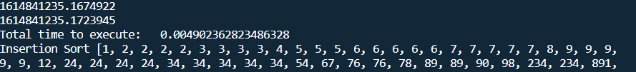

For bubble sort

